\*\*Done in MySql

SELECT

ep.planNo,

count(el.planNo),

sum(el.numberFLD)

FROM EventPlan AS ep, EventPlanLine AS el

WHERE ep.planNo = el.planNo

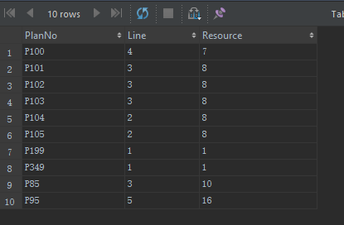 GROUP BY ep.planNo;